Lab 16: Mobile Forensic Analysis

Alex Arnold

1.14 - System Settings Table

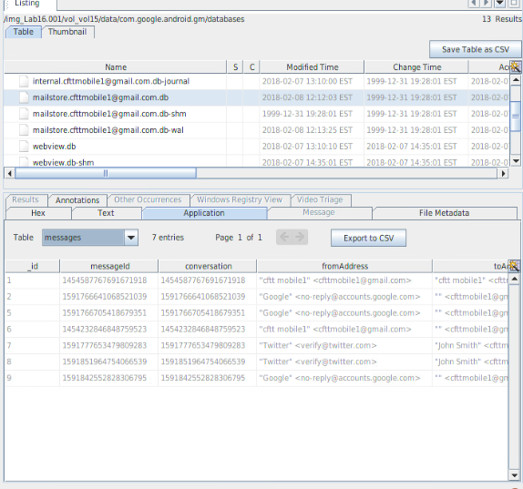

1.23 - Email Messages

2.6 - Messages